Q 1. Show first name, last name, and gender of patients whose gender is 'M'
- SELECT first_name,last_name,gender FROM patients where gender='M'
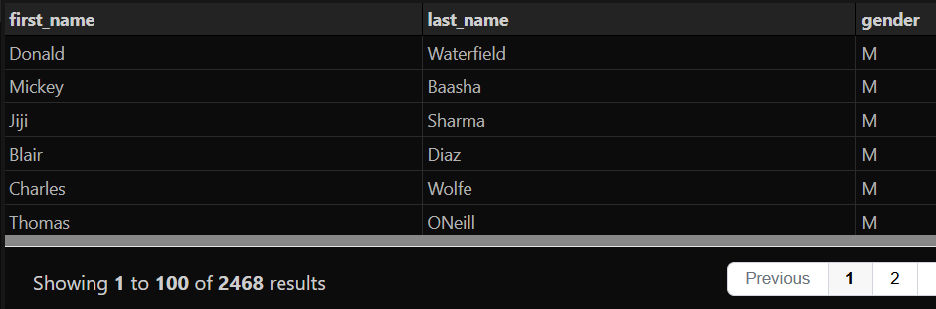
Q 2. Show first name and last name of patients who does not have allergies. (null)
- SELECT first_name,last_name FROM patients where allergies is null
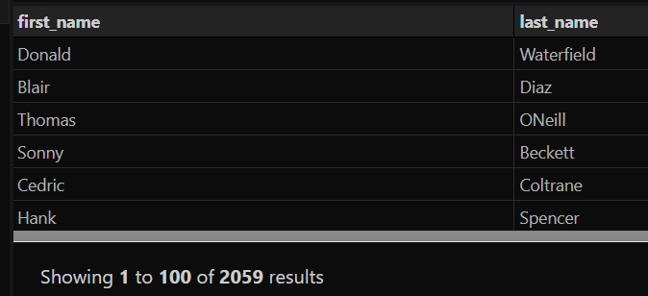
Q 3. Show first name of patients that start with the letter 'C'
- SELECT first_name FROM patients where first_name like "c%"
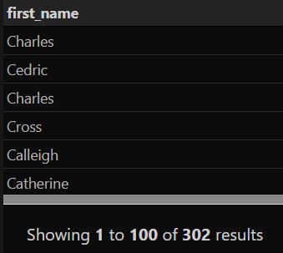
Q 4. Show first name and last name of patients that weight within the range of 100 to 120 (inclusive)
- SELECT first_name, last_name FROM patients where weight>=100 and weight<=120
- SELECT first_name,last_name FROM patients WHERE weight BETWEEN 100 AND 120;
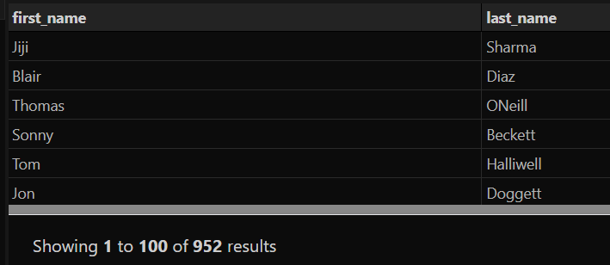
Q 5. Update the patients table for the allergies column. If the patient's allergies is null then replace it with 'NKA'
- update patients set allergies='NKA' where allergies is null
Q 6. Show first name and last name concatinated into one column to show their full name.
- select concat(first_name," ",last_name) as full_name from patients
- SELECT first_name || ' ' || last_name FROM patients;
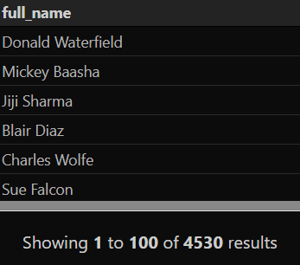
Q 7. Show how many patients have a birth_date with 2010 as the birth year.
- SELECT count(patient_id) FROM patients where birth_date like "2010%"
- SELECT COUNT(*) AS total_patients FROM patients WHERE YEAR(birth_date) = 2010;

Q8 . Show first name, last name, and the full province name of each patient.
- select p.first_name,p.last_name, n.province_name from patients p join province_names n on p.province_id = n.province_id;
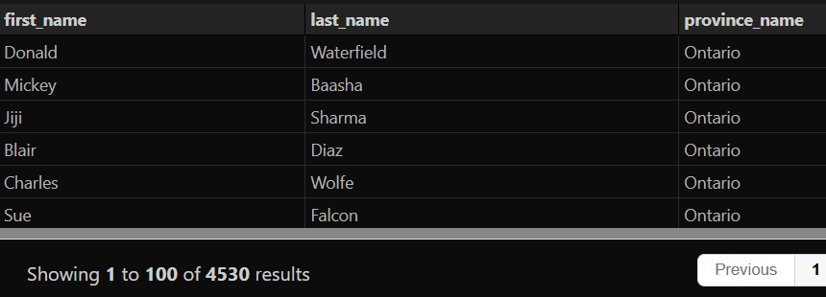
Q9. Show the first_name, last_name, and height of the patient with the greatest height.
- select first_name, last_name, height from patients where height= (SELECT max(height) FROM patients)
Q10 . Show all columns for patients who have one of the following patient_ids: 1,45,534,879,1000
- select * from patients where patient_id in (1,45,534,879,1000)
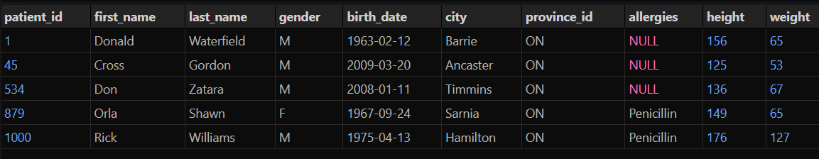
Q 11. Show the total number of admissions
- select count(*) from admissions

Q 12.Show all the columns from admissions where the patient was admitted and discharged on the same day.
- select * from admissions where admission_date==discharge_date
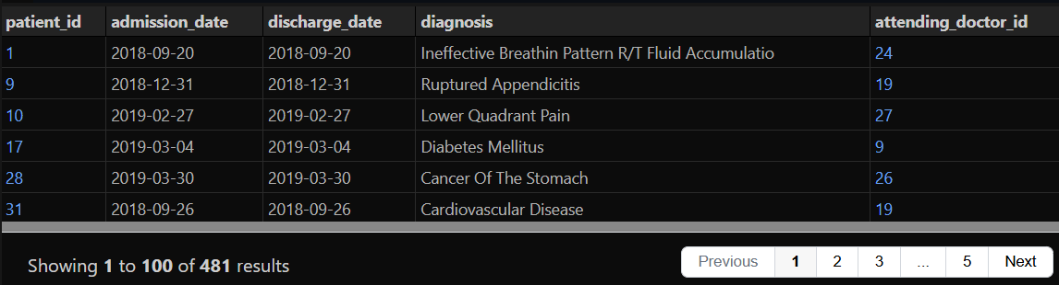
Q 13. Show the patient id and the total number of admissions for patient_id 579.
- select * from (select patient_id,count(admission_date) from admissions group by patient_id ) where patient_id=579
- SELECT patient_id, COUNT(*) AS total_admissions FROM admissions WHERE patient_id = 579;

Q 14. Based on the cities that our patients live in, show unique cities that are in province_id 'NS'.
- SELECT distinct city from patients where province_id = 'NS'
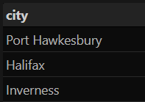
Q 15.Write a query to find the first_name, last name and birth date of patients who has height greater than 160 and weight greater than 70.
- SELECT first_name, last_name, birth_date from patients where height>160 and weight>70
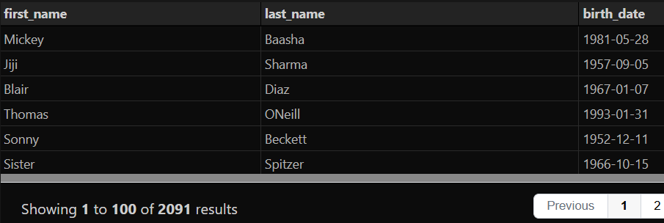
Q 16. Write a query to find list of patients first_name, last_name, and allergies where allergies are not null and are from the city of 'Hamilton'
- SELECT first_name, last_name, allergies from patients where allergies is not null and city='Hamilton'
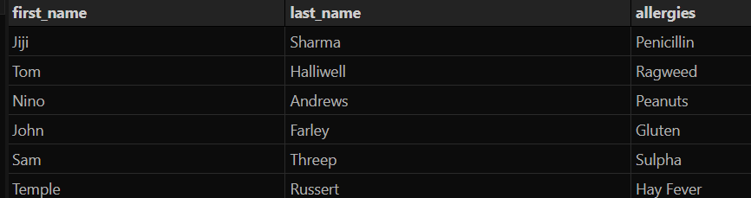

Q 17. Show the category_name and description from the categories table sorted by category_name.
- SELECT category_name, description FROM categories order by category_name
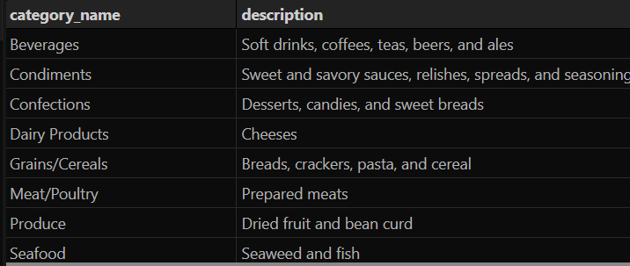
Q 18. Show all the contact_name, address, city of all customers which are not from 'Germany', 'Mexico', 'Spain'
- SELECT contact_name,address,city FROM customers where country not in ('Germany', 'Mexico', 'Spain')
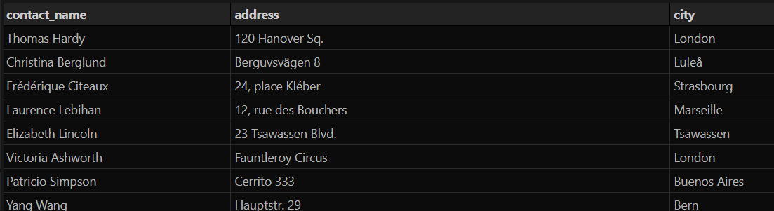
Q 19. Show order_date, shipped_date, customer_id, Freight of all orders placed on 2018 Feb 26
- SELECT order_date,shipped_date,customer_id,freight FROM orders where order_date = '2018-02-26'
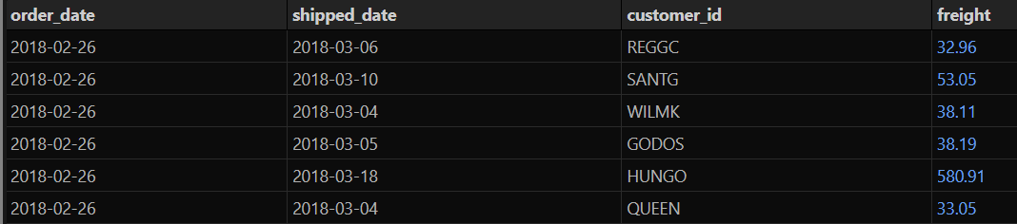
Q 20. Show the employee_id, order_id, customer_id, required_date, shipped_date from all orders shipped later than the required date
- SELECT employee_id, order_id, customer_id,required_date,shipped_date from orders where shipped_date > required_date
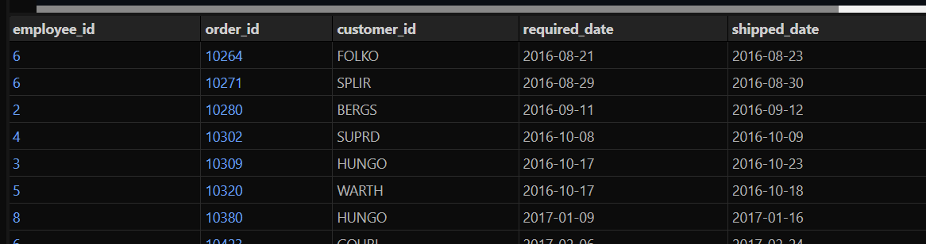
Q 21. Show all the even numbered Order_id from the orders table
- select order_id from orders where order_id % 2 =0
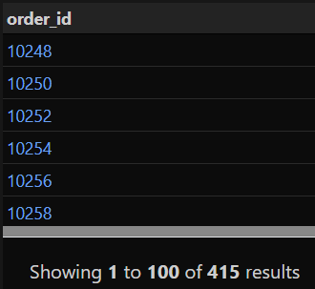
Q 22. Show the city, company_name, contact_name of all customers from cities which contains the letter 'L' in the city name, sorted by contact_name
- select city,company_name,contact_name from customers where city like "%l%" order by contact_name
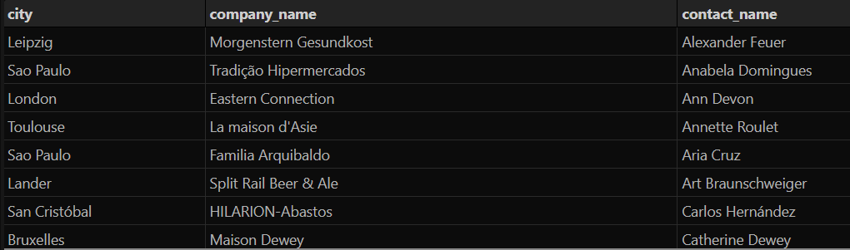
Q 23. Show the company_name, contact_name, fax number of all customers that has a fax number. (not null)
- select company_name,contact_name,fax from customers where fax not null
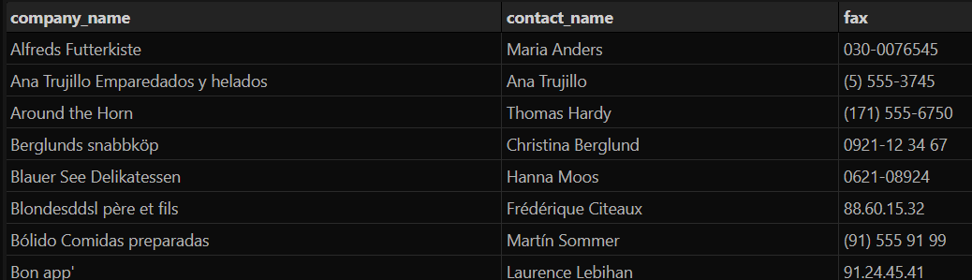
Q 24. Show the first_name, last_name. hire_date of the most recently hired employee.
- select first_name, last_name, max(hire_date) from employees
Q 25. Show the average unit price rounded to 2 decimal places, the total units in stock, total discontinued products from the products table.
- select round(avg(unit_price),2),sum(units_in_stock), sum(discontinued) from products

